Earth image in banner: <http://photojournal.jpl.nasa.gov/jpegMod/PIA11066_modest.jpg>

I. INDEX

Welcome!

Have you ever wondered about a solution to world hunger? Or thought about a cure to cancer and AIDS? Maybe you’ve pondered environmental issues, like how to reduce pollution. The solution to all these problems and more may lie in the future of a field called nanotechnology, tiny particles that can lead to big changes.

What is nanotechnology?

Simply put, nanotechnology is science dealing with materials on a very small scale – the same scale used for atoms and molecules. Nanometers (nm), the main unit of measurement, are one billionth of a meter each, and objects classified as “nanomaterials” are 1-100 nm. The concept of nanotechnology can be traced to about 50 years ago, and since then, scientists have been scrambling to pioneer new advances that will transform the way we live.

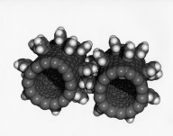 <http://www.nasaimages.org/luna/servlet/detail/nasaNAS~5~5~21461~126278:Fullerene-Nanogears?qvq=q:nano;lc:nasaNAS~5~5,NVA2~14~14,nasaNAS~20~20,NVA2~1~1,NVA2~13~13,nasaNAS~16~16,NSVS~3~3,NVA2~8~8,nasaNAS~8~8,NVA2~4~4,nasaNAS~6~6,NVA2~18~18,nasaNAS~4~4,nasaNAS~N2~2,nasaNAS~13~13,NVA2~17~17,nasaNAS~12~12,nasaNAS~22~22,NVA2~16~16,NVA2~9~9,nasaNAS~10~10,nasaNAS~7~7,NVA2~15~15,nasaNAS~9~9,NVA2~19~19&mi=1&trs=5>

This website was created as a project for the 2009 Student Bio Expo as well as to educate visitors on the quickly developing field of nanotechnology. Please click on the links to the left to learn and explore the world of nanotech. To find out more about the Bio Expo, please see <http://www.nwabr.org/studentbiotech/default.html>.

II. Overview

A. History EXPAND TIMELINE! ADD IN SPECIAL MICROSCOPES IRA FLATOW

Here is a timeline that includes the major advances in nanotechnology since 1959:

1959- American physicist Richard P. Feynman gives a speech at the American Physical Society, and is credited with originating the concept of nanotechnology

1974-Japanese scientist Norio Taniguchi is the first to use the term ‘nanotechnology’ in his paper, “On the Basic Concept of Nanotechnology”

1981-Kim Eric Drexler, a genetic engineering student at MIT, popularizes the theory of nanotechnology RECHECK DATE

1985- Richard Errett Smalley makes the first major development in nanotechnology by finding a way to produce carbon in a third form (besides graphite and diamond). Smalley called this synthetic carbon molecules buckyball, or fullerene.

2000- US President Bill Clinton creates the National Nanotechnology Initiative (NNI) EXPAND THIS & SOURCE

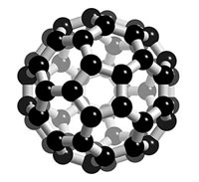

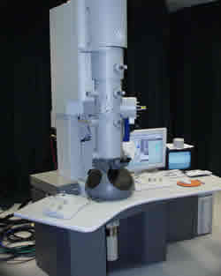

http://www.phy.cuhk.edu.hk/centrallaboratory/TecnaiF20/TecnaiF20c.jpg

B. How it works

What makes nanotechnology so special? At first glance, nanomaterials seem to be similar to regular-sized materials, but in reality, they aren’t. At the nanoscale, molecules and atoms behave differently than they do when they are visible to the human eye. Nanomaterial’s physical properties are different at that scale, creating the need for more research and information about nanotechnology.

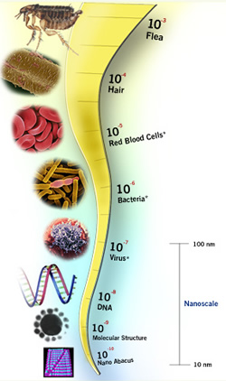http://www.discovernano.northwestern.edu/whatis/index_html/howsmall_html

Nanoscale devices, such as nanobots, sensors and medical devices need some sort of energy source to power them, so research, at places like the Georgia Institute of Technology, is being done now on nanogenerators. "Nanogenerator" is the general term used for the power plants that harvest and supply energy to nanoscale devices. They replace the need for large batteries, making the devices more efficient.

How Nanomaterials are made

There are currently two main approaches to creating nanomaterials. The first, the top-down approach (also called nanofabrication or microfabrication) is made of two stages. First, a single layer of material is grown on a substrate (a supporting base) during the growth stage. Next, in the lithography transfer stage, the one dimension layer is added to another uniform layer to form a second/third dimension. The top-down approach involves cutting down larger materials to form the layers. The second main way nanomaterials are made is referred to as the bottom-up approach. With this method, atoms and molecules are manipulated one at a time to build nanomaterials.

Both approaches have their flaws, however. They both are costly, and nanofabrication is not precise 100% of the time. The bottom-up approach is generally new, and because of the unstable nature of nanomaterials, they are sometimes hard to control and manipulate. On the other hand, if the bottom-up approach becomes more stable, it will create cheaper and more efficient products.

III. Impact

A. Medicine/Healthcare

Nanotechnology has the potential to revolutionize the medical field. Smaller tools created with nanotechnology will reduce the price of healthcare and will help in researching diseases, like cancer. New materials, made with nanotech, will also have a substantial impact on implants, such as those used to hold bones together. Before, titanium was used, which didn’t bond well to the bone. Now, a special nanocoating has been created to cover the titainium, which helps the bone to adhere and respond better to implants.

The two major areas in healthcare that nanotechnology will affect are diagnostic and therapeutic.

Diagnostic Impact

“Diagnosis” is the analysis/detection of diseases or other medical conditions. (dictionary.com). Right now, the diagnosis of some diseases entails sending a sample of blood from a patient to a lab for analysis. This takes about two weeks. With new developments in nanotechnology, however, this procedure can be reduced to a few seconds. By sizing down circuits and machines to the nanoscale, scientists and doctors can take a single drop of blood and diagnose a patient in just a few seconds. This new diagnostic method will be particularly useful in third world countries, where labs may be few and hard to come by.

Therapeutic Impact

Nanotechnology will also improve the therapeutic area of healthcare, or the treating of diseases. Because of the different properties of matter at the nanoscale, nanomaterials can be created that make sure specific treatment goes to specific places in the body. Now, scientists are able to program nanostructures to bind to specific cells so that they can treat diseases more effectively. For example, nanoscale devices will help make treatments such as chemotherapy more efficient by targeting specific areas of tumors without hurting healthy tissues.

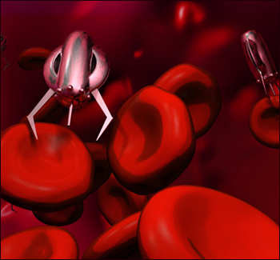

<http://www.topnews.in/conductive-property-organic-molecules-breakthrough-nanotechnology-236757>

B. Renewable Energy POSSIBLY EXPAND

Nanotech has also been used to help the environment. Recently, a new coating that makes solar panels more efficient has been developed with nanotechnology. Researchers from the Future Chips Constellation (FCC) at Rensselear Polytechnic Institute in New York have found that the new coating can absorb about 96.21% of all the sun exposure it receives, much higher than the 67.4% regular silicon solar panels now receive. The coating is made out of seven layers of nanoscale silicon dioxide and titanium dioxide rods and can absorb all types of sunlight from many different angles (Knight).

http://www.greeninnovation.co.uk/new/images/page58image.jpg

C. Space Elevator IS THIS SECTION NEEDED?

In November of 2008, engineers from all over the world attended a conference in Japan to discuss and design a lift that will transport anything directly into space. The ‘space elevator’, as it is called, has received worldwide coverage; NASA has posed this concept with a $4 million prize as a challenge to encourage more designs. The Japan Space Elevator Association, Spaceward Foundation and Liftport Group are three major companies focused on this project.

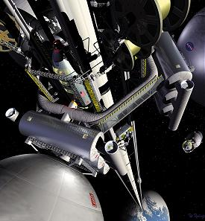 <http://science.nasa.gov/headlines/y2000/ast07sep_1.htm>

Those working on the project right now believe that the power source of the elevator will most likely come from a carbon nanotube cable, which has enough strength to span the length from Earth to space. However, scientists are unsure of how to make a cable long enough. Once completed, the cable would be anchored to Earth and reach into space with a weight to balance it on the other side. Inertia is theorized to keep the cable tight. The space elevator would be used to transport people into space, dispose of nuclear waste and place solar panels in space to provide power to homes (Steere).

IV. Safety (and how nanotechnology is used in the world around us today)

1. Products

Companies have already begun to use nanotechnology in or to make more than 200 consumer products in the US (800 in Canada) (Cotter). One of the reasons for this is the changing physical property nanomaterials have that can improve finished products. Although most consumer products with nanotechnology are constructed with carbon, silver and silica, they have a wide range of applications (Binns). 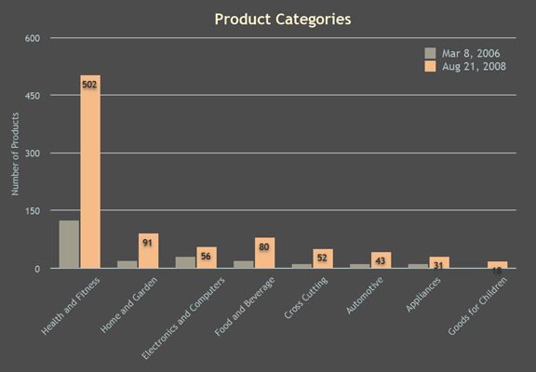

<http://www.nanotechproject.org/inventories/consumer/analysis_draft/>

Products in the health and fitness category include popular cosmetics (creams, lotions, hair appliances, etc.) that are circulating widely through the market today. Other products include a paint line, manufactured by Behr, which blends nano-sized ingredients to make the paint more resistant to mildew and grease. Another product is canola active oil by Sherman Industries that has been manufactured with nanodrops that contain vitamins and minerals. Without the nanodrops, they would be insoluble (Binns).

1. Concerns

In December of 2008, the National Research Council (NRC) in the US reported that the US government is not standardizing and regulating nanotech enough, causing a negative reaction from consumers. Many similar organizations around the world, like the Royal Commission on Environmental Pollution in Great Britain and the Council of Canadian Academies agree that more research should be done on nanotechnology, and that a clear set of regulations should be created (Cotter). 5% of US funding for nanotechnology is used to research its effects on health and safety (Pellerin).

Some of their concerns stem from the fact that nanomaterials cannot be seen by the naked eye, arousing issues in disposing of nanomaterials.

Other concerns come from the general public, who are somewhat scared of nanotechnology after being introduced to it through fictional works, such as Michael Chrichton’s *Prey*. Chrichton’s book tells a fictional account of nanoparticles that can behave on their own and eventually escape from their human creators and develop into self-reliant creatures that feed off of animals (including humans). Some consumers are also reluctant to try nanotech products because of the lack of regulations and general research/knowledge in existence. SOURCE?

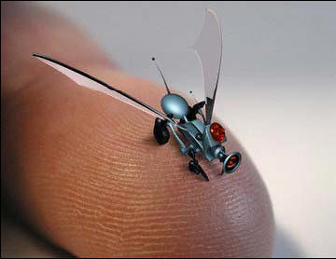

<http://scienceblogs.com/framing-science/2008/05/at_the_new_york_times_and_glob.php>

V. [Nanotechnology &] Money

Because of its potential, countries all over the world are funding the research of nanotechnology. Some governments, like those of Japan and Russia, have made it a priority to develop nanotech. In 2007, the world collectively spent $13.8 billion USD on research. In the US alone, $1.5 billion came from the government (up from $500 million in 2001) and $3 billion came from private investors (Pellerin). The top five countries competing for dominance in the field of nanotechnology are the US, European Union (EU), Japan, Russia and China.

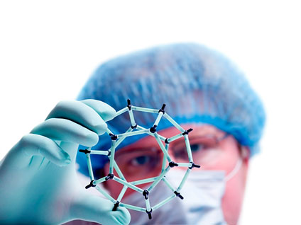http://www.nanotechcompanies.us/nanotech-scientist-424.jpg

VI. Future [of Nanotechnology]

The possible applications of nanotechnology seem endless, especially in healthcare, reducing our environmental impact and national security.

Scientists believe that in the future, nanotechnology will produce

* surgical instruments the size of molecules
* the creation of food from molecules, possibly stopping famine
* pollution free industrial manufacturing
* devices that clean up pollution
* nanobots that cure cancer, AIDS and bacteria/viruses.
* personalized medicine, specific to a person’s DNA
* smart houses that adapt to temperature and environment

According to Mihail C. Roco, a senior advisor for nanotechnology at the National Science Foundation, there are four stages of nanotech development (Roco):

1. Development of nanomaterials with a stable structure that are usually used as part of a product (began in 2000)
2. Focused research on nanostructures that change size, shape or conductivity during its use (began in 2005)
3. Development of systems of nanostructures that form self-dependent wholes that operate by themselves (projected to start around 2010)
4. Development of molecular nanosystems that may lead to new types of genetic therapies and anti-aging treatments (projected around 2015-2020)

VII. Reflection DEFINITELY EXPAND

When I was first assigned the Bio Expo project in genetics class, way back in October, I was extremely excited. Unlike the science fairs I had participated in during middle school, I really wanted to give this project my all because it seemed different and more challenging. There was such a wide selection of categories that, at first, I didn’t know which one to choose. I hadn’t wanted to do a lot of writing, however, because I felt that I already did too much writing in school. By January, I had narrowed the categories down to two: a website or artwork. Art seemed like a fun idea, but when I couldn’t come up with any ideas for an engaging piece of art, I turned to the website. This has been a very challenging project for me because when I first started out, I had little to no knowledge of html, and I couldn’t get things to look exactly the way I wanted them to. However, I have overcome most of those challenges and the end result is right here on this computer monitor!

Resources

Mentorship:

Laura Burke

Graduate Research Assistant

Washington State University

(775) 224-9772

[leburke@wsu.edu](mailto:leburke@wsu.edu)

My mentor for this project was Laura Burke, and although we were unable to meet in person, she gave me a lot of advice and helped me to develop my ideas. We have exchanged many emails since January, and although her area expertise is not nanotechnology, she was able to help me with the structure of my site. Her ideas were insightful and I’m grateful for receiving such a kind mentor.

Interview:

Ethan Allen

Manager, Education & Outreach

The Center for Nanotechnology at the University of Washington

Box 351721

Seattle, WA 98195

(206) 616-9769

[ethane@u.washington.edu](mailto:ethane@u.washington.edu)

I interviewed Ethan Allen on 03/30/09 through a phone call to clarify some aspects of nanotechnology. Since he works at the Center for Nanotechnology at the UW, he easily answered and expanded on all my questions. The Center, as he described, basically brings together researchers of nanotechnology and students from many different educational departments at the UW. In the nanotech user facility, a part of the Center, specialized high end equipment and microscopes are available for people to use. His main job there is to facilitate education programs by working with high school teachers and graduate students. Although I had to reschedule the interview a couple of times, he was very patient and took time out of his schedule to help me.

VIII. Bibliography DON’T FORGET